**INPUT DATA:**

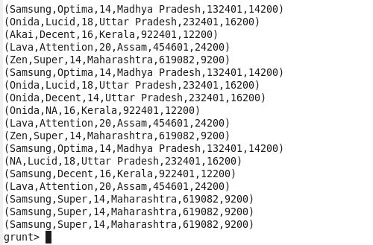

**CONCAT:**

COMMAND:

D:\assignment\10.2concat.png

OUTPUT:

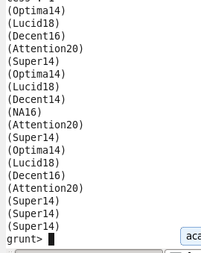

**TOKENIZE**

DATA

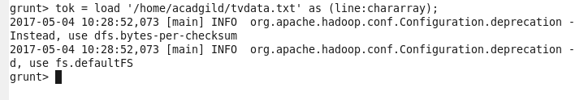

COMMAND:

D:\assignment\10.2tok.png

OUTPUT:

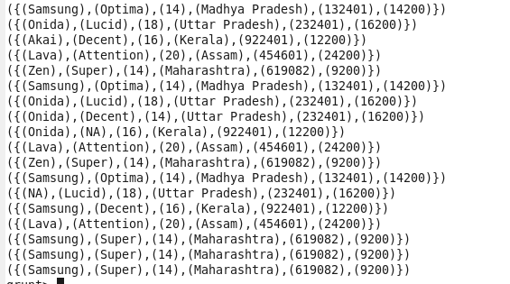

**SUM:**

COMMAND:

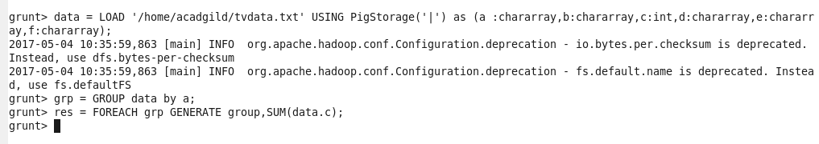

OUTPUT:

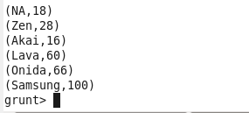

**MAXIMUM:**

COMMAND:

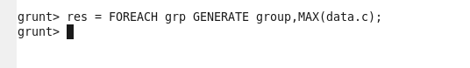

OUTPUT:

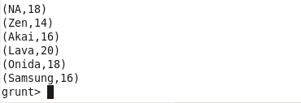

**MINIMUM:**

COMMAND:

D:\assignment\10.2min.png

OUTPUT:

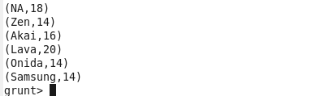

**LIMIT:**

COMMAND:

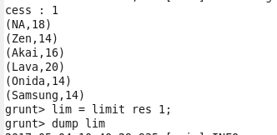

OUTPUT:

D:\assignment\10.2limres.png

**STORE:**

COMMAND:

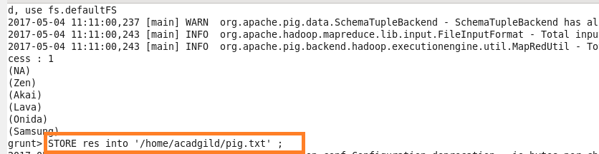

OUTPUT:

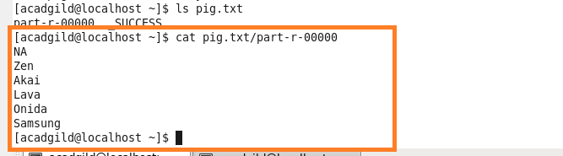

**FLATTEN:**

COMMAND:

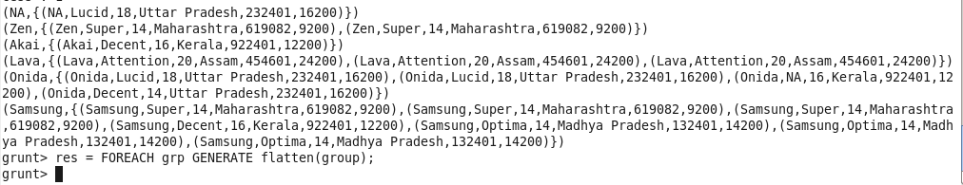

OUTPUT:

